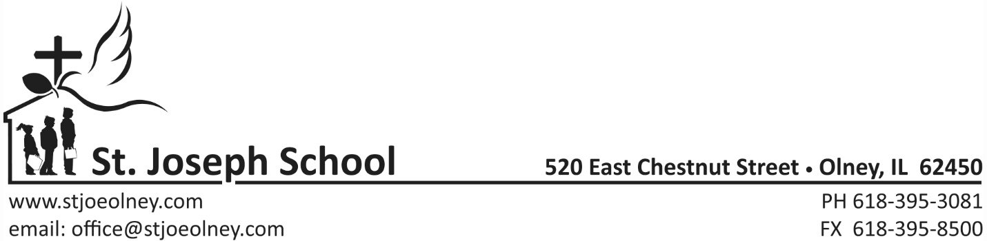
2019-2020
K-8th grade tuition
Parishioner- 1 student family: $3150 - $750 IL Tuition Tax Credit = $2400
Parishioner- 2 student family: $4350 - $750 IL Tuition Tax Credit = $3600
Parishioner- 3 or more student family: $5260- $750 IL Tuition Tax Credit = $4510

Non-Parishioner- 1 student family: $4100 - $750 IL Tuition Tax Credit = $3350
Non-Parishioner- 2 student family: $5620 - $750 IL Tuition Tax Credit = $4870
Non-Parishioner-3 or more student family: $6950 - $750 IL Tuition Tax Credit = $6200
St. Joseph Pre School
2019-2020 Rates
$50 non –refundable registration fee
1 half day: $530/year
2 half days: $1060/year
2 full days: $2120/year
3 half days: $1590/year
3 full days: $3180/year
4 half days: $ 2120/year
4 full days: $ 3715/year
5 half days: $2650/year
5 full days: $4245/year
Tuition payments can be made in 10 equal monthly installments

